ELA
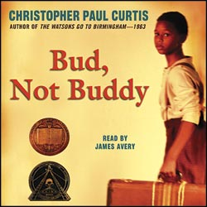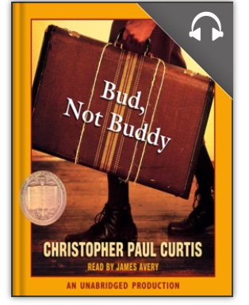
← Audio Version
Has a picture of
headphones
This is a free app that you can connect to with your library card. Many books we read in school are offered in an Audio (listening) version. This is helpful for students to listen to the story AS THEY READ!

You must have a library card to link your card to your overdrive account. The number on your library card allows you to borrow books and audio books for free through the “Overdrive” app.

